
INTERNATIONAL UNIVERSITY
SCHOOL OF ELECTRICAL ENGINEERING (EE)

EE091

ELECTRONIC DEVICES

LAB 5

COMMON EMITTER
AMPLIFIER - PNP

Full name:………………………………..
Nguyễn Minh Đức - ITITIU21045………………………...
Nguyễn Quang Tâm - ITITIU21304………………………..
Tôn Long Thuận - ITITIU21322………………………...

- OBJECTIVES

This lab introduces the operation of common emitter amplifier. You will know how to build a CE circuit, measure the gain and compare to the theory calculation

- MATERIAL AND EQUIPMENT

  - Oscilloscope

  - Power Supply

  - Multimeter

  - 2N3906

Electronic devices Page 1 of 8
INTERNATIONAL UNIVERSITY
SCHOOL OF ELECTRICAL ENGINEERING (EE)

  - Assorted Resistors

III. PRELAB

For prelab, you are responsible for performing BOTH the calculation of figure 1 circuitry for both NPN transistor 2N3904 to PNP transistor 2N3906 (with and without the 4.7uF capacitor) as well as simulations for all scenarios. You are allowing to use the figures I had provided to you at the end of lab manual for preference; however, you must perform your simulation of circuitries. The performance of PRELAB this time in advanced is recommended, as the lab procedure will be quite difficult without proper preparation. Assuming = 100, = 0.7 .

IV. PROCEDURE

In this section, you will analyze a common emitter amplifier, a popular transistor amplifier circuit.
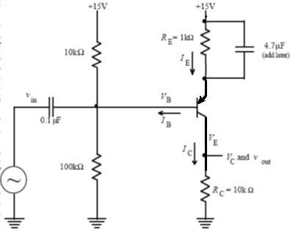

Figure 1: Common emitter amplifier.

4.1. DC analysis:

Electronic devices Page 2 of 8
INTERNATIONAL UNIVERSITY
SCHOOL OF ELECTRICAL ENGINEERING (EE)
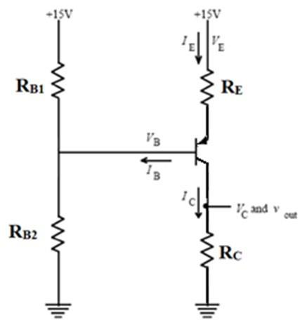

Figure 2: Common emitter amplifier – DC Analysis.

Using a digital multimeter to measure DC values of voltage , , , , , then calculate current values , , .

Electronic devices Page 3 of 8
INTERNATIONAL UNIVERSITY
SCHOOL OF ELECTRICAL ENGINEERING (EE)
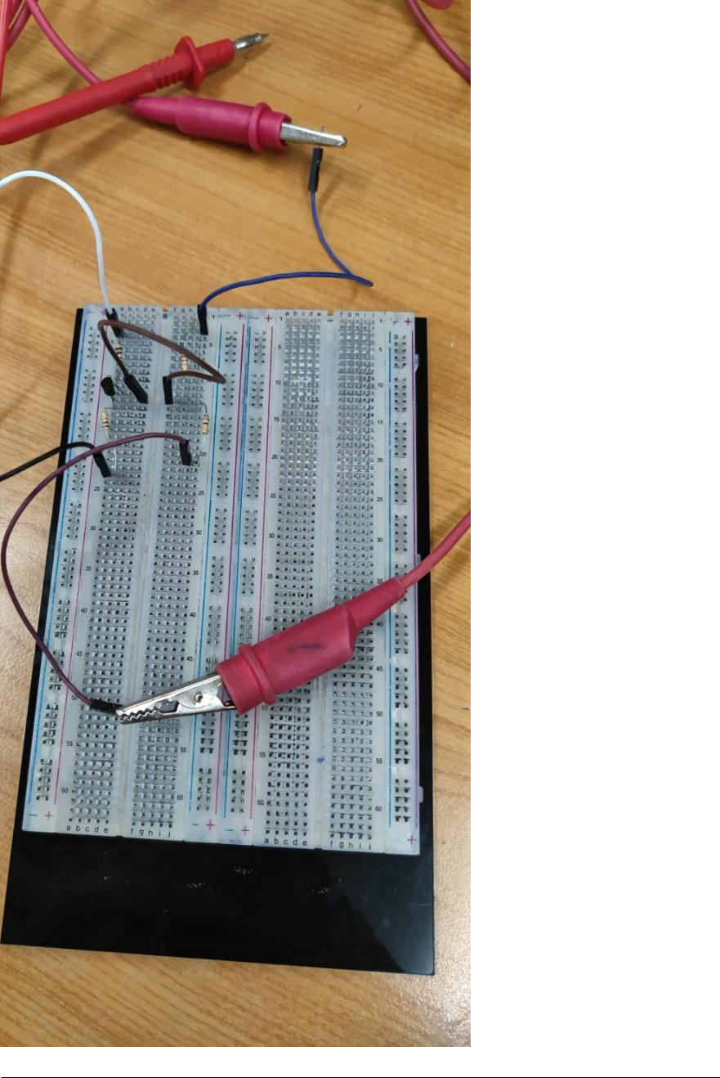

Electronic devices Page 4 of 8
INTERNATIONAL UNIVERSITY
SCHOOL OF ELECTRICAL ENGINEERING (EE)

 | V_{B} | V_{E} | V_{C} | V_{BE} | V_{CE} | V_{BC} | I_{B} | I_{C} | I_{C} | β
Calculation | 13.69 | 14.39 | 6.031 | -0.7 | -8.359 | 7.659 | 6.031 | 6.091 | 6.301 | 100
 |  |  |  |  |  |  | x10⁻⁶ | x10⁻⁴ | x10⁻⁴ | 100
Simulation | 13.63 | 13.89 | 6.135 | -0.53 | -7.842 | 7.842 | 6.2 | 5.93 | 6.042 | 250
 |  |  |  |  |  |  | x10⁻⁶ | x10⁻⁴ | x10⁻⁴ | 250
Measurenent | 13.57 | 14.114 | 6.13 | -0.583 | -8.063 | 8.063 | 4.02 | 6.97 | 6.92 | 170
 |  |  |  |  |  |  | x10⁻⁶ | x10⁻⁴ | x10⁻⁴ | 170
4.2. AC analysis:

- Connect the function generator to and use a 1V peak-to-peak 1kHz sine wave as the input signal, with the coupling capacitor 1 = 0.1 . Monitor and simultaneously with the oscilloscope and sketch them on the same set of axes.
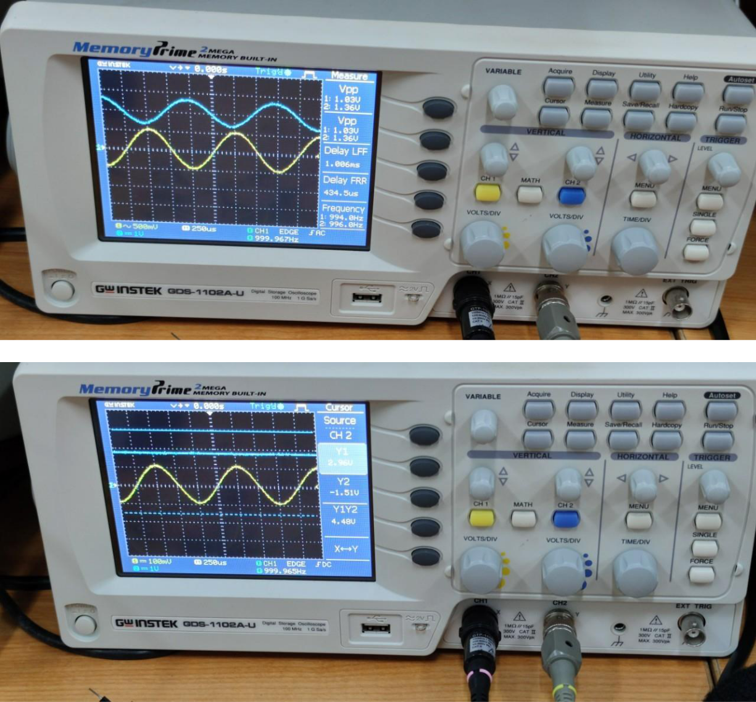

Electronic devices Page 5 of 8
INTERNATIONAL UNIVERSITY
SCHOOL OF ELECTRICAL ENGINEERING (EE)

- Measure the gain of this amplifier. Compare it to the calculated gain, phase difference from input to output. ⁄ . Note the

- The output of an ideal amplifier should always look just like the input multiplied by the gain. However, real amplifiers only work correctly over a limited range of output voltages and frequencies. Explore the behavior of the amplifier a little more by performing the following steps:

  - Using different waveforms (Sine wave, square wave and Triangle wave). For each input waveform, try adjusting and simultaneously with the oscilloscope and sketch them on the same set of axes. Also, report on their respective gain on each case. Is the phase difference from input to output the same when we change the input waveform?

Waveforms | Sine wave | Square wave | Triangle wave
Gain (simulation) | 9.3V | 12V | 9.2V
(f = 1kHz) | 9.3V | 12V | 9.2V
Gain
(measurement)
(f = 1kHz)

- Using different amplitudes for , report the gain of each cases according to the following table:

, _ | Gain | Gain | , _ | Gain | Gain
 | (Simulation) | (Measurement) |  | (Simulation) | (Measurement)
1 | 9.5 | 4.42 | 8 | 2.32
2 | 7.6 | 6.92 | 10 | 1.92
4 | 4.198 | 3.78 | 12 | 1.593
6 | 3.2 | 2.24 | 14 | 1.42

- Return theback to the original value. Now, try using different load resistor values , and report the gain of each cases according to the following table.

Gain

(Simulation)

Gain

(Measurement)

Gain

(Simulation)

Gain

(Measurement)

Electronic devices Page 6 of 8

INTERNATIONAL UNIVERSITY
SCHOOL OF ELECTRICAL ENGINEERING (EE)

1 Ω | 0.99 |  | 5.6 Ω | 2.32
2.2 Ω | 2.16 |  | 6.8 Ω | 1.92
3.3 Ω | 4.198 |  | 10 Ω | 1.593
4.7 Ω | 3.2 |  | 22 Ω | 1.42

- Return the and back to the original value. Now, try using different frequency values, and report the gain of each cases according to the following table. Given that the formula to calculate the gain is:

 |  | ( ) = 20 ( |  |  |  | )
Frequency | Gain | Frequency | Gain | Frequency |  | Gain | Frequency | Gain
100 |  | 1000 |  | 10,000 |  |  | 60,000
200 |  | 2000 |  | 20,000 |  |  | 70,000
400 |  | 3000 |  | 30,000 |  |  | 80,000
600 |  | 4000 |  | 40,000 |  |  | 90,000
800 |  | 5000 |  | 50,000 |  |  | 100,000
Now, add the Bypass capacitor 2 = 4.7 in parallel with the resistor . See how the gain changes when you add this capacitor. Can you explain this? Repeat the process of changing the input frequency from 100Hz to 100KHz like above. Determine the gain
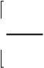
^{v}out


^{v}in dB and plot the frequency response. Determine approximately the minimum and

maximum frequencies for which the gain is constant. Try to guess what causes of these limits.
Frequency | Gain | Frequency | Gain | Frequency | Gain | Frequency | Gain
100 |  | 1000 |  | 10000 |  | 60000
200 |  | 2000 |  | 20000 |  | 70000

Electronic devices Page 7 of 8
INTERNATIONAL UNIVERSITY
SCHOOL OF ELECTRICAL ENGINEERING (EE)

400 |  | 3000 |  | 40000 |  | 80000
600 |  | 4000 |  | 40000 |  | 90000
800 |  | 5000 |  | 50000 |  | 100000

- Finally, add the Coupling capacitor 3 = 4.7 connected to the Collector terminal. See how the output signal change when you add this capacitor. Can you explain this? Capture the output signal for your report.

Electronic devices Page 8 of 8

